**Theme 4 – What makes a leader? – Daniel Goleman**

**The idea in Brief:**

* Defining the ideal leader many would empahsise intelligence, toughness, determination, and vision. Often left out is softer more personal qualitites- but these are essential.
* A certain degree of analytical and technical skill is a minimum requirement for success, what is called ‘ emotional intelligence’ may be the key attribute that distinguishes outstanding performance from those who are merely adequate.
* Example – 1996- study of a global food and beverage company, where senior managers had a certain critical mass of emotional intelligence, their divisions outperformed yearly earnings goals by 20%.
* Division leaders without that critical mass underperformed by almost the same amount.

**The idea in practice:**

* Five components to emotional intelligence; self awareness, self regulation, motivation, empathy and social skill.
* Organisations too often implicitly discourage their people from developing them.
* ***Self-management skills:***
  + **1.Self-awareness.** Emotional intelligence begins with this trait. People with high degree of self awareness know their weakness and aren’t afraid to talk about them. Someone who understands that he works poorly under tight deadlines will work hard to plan his time carefully and will let his colleagues know why. Many exe looking for potential leaders mistake such candor for ‘wimpiness’.
  + **2. Self- Regulation-** this attribute flows from self awareness, but runs in a different direction. People with this trait are able to control their impulses or even channel them for good purposes.
  + **3.** **Motivation –** a passion for achievement for its own sake – not simply the ability to respond to whatever incentives a company offers – is a kind of motivation that is essential for leadership.
* ***The ability to relate to others:***
  + **4. Empathy-**  emotional intelligence requires a facility for dealing with others. That starts with empathy – taking into account the feeling of others when making decisions – as opposes to taking on everyone’s troubles.
  + **5. Social Skill-**  the ability to build raport with others, to get them to cooperate, to move them in a direction you desire. Managers who simply try to be sociable- while lacking the other components of emotional intelligence – are likely to fail. Social skill, by contrast, is friendliness with a purpose.
* ***Can you boost your emotional intelligence?***
  + Absolutely, but not with traditional training programs that target the rational part of the brain, extended practice, feedback from colleagues and your won enthusiasm for making the change are essential to becoming an effective leader.

**What makes a leader?**

* It was goleman who first brought the term ‘emotional intelligence’ to a wide audience. Truely effective leaders are also distinguished by a high degree of emotional intelligence which includes self, awareness, self regulation, motivation, empathy and social skill.
* Goleman found direct ties between emotional intelligence and measurable business results.
* Everyone knows a story of a highly intelligent, highly skilled executive who was promoted to leadership but failed. Or the average intelligence guy who was promoted and then soared.
* Identifying the people with the right stuff to be leadersis more art than science.
* Most effective leaders have a high degree of emotional intelligence. Its not the iq and intelligence that are important.
* They do matter as ‘threshold capabilities’ , they are entry requirements for exe positions.

**Evaluating Emotional Intelligence:**

* Most companies have hired psychologist to develop competency models to identifying, training and promoting people in leadership.
* In research, objective was to determine which personal capabilities drove outstainding performance within these orgs.
* Capabilities grouped into 3 categories: purely technical skills (accounting, business planning), cognitive abilities (analytical reasoning) and competencies demonstrating emotional intelligence (ability to work with others).
* Psychologist tested effective leaders and created a list of ingrediants for success. When goleman analysed the data he found when he calculated the ratio of tech skills, ig and emotional intelligence as ingredients of excellent performance, emotional intelligence proved to be twice as important as the others for jobs at all levels.
* The higher the rank of a person considered to be a star performer, the more emotional intelligence capabilities showed up as th reason for hsi or her effectivensss.
* Companring star performers with average ones in senior leadership, nearly 90% of the difference in their profiles was attributable to emotional intelligence factors rather than cognitive abilities.

**Self awareness:**

* First component of emotional intelligence.
* Means having a deep underastanding of ones emotions, strengths, weaknesses and drives.
* People with strong self awareness are neither overly critical nor unrealistically hopeful.
* Recognise how their feeling affect them, other people and their job performance.
* Knows that tight deadlines bring out the worst in him plans his time carefully and gets his work done before it.
* Nother will be able to work with a demanding client.
* Self awareness extends to a persons understanding of his values and goals.
* A person who lacks self awareness is apt to make decisions that bring on inner turmoil by treading on buried values.
* How can on recognies self awareness? Is shows itself as candor and an ability to asses oneself realistically. People with high self awareness are able to speak accurately and openly about their emotions and the impact they have on their work.
* Self awareness can also be identified during performance reviews. They are comfortable talking about their limitations and strengths.
* Can also be recognised by their self confidence. They’ll play to their strengths.
* Senior exe don’t often give self awareness the credit it deserves when thay look for potential leaders. Called whips or not tough enough to lead. Infact the opposite is true.
* People generally admire candor. Leaders are constantly required to make judgment calls that require a candid assessment of capabilities- their own and those of others.

**Self regulation:**

* Biological impulses drive our emotions.
* Self regulation which is like an ongoing inner converstion is the component of emotional intelligence that frees us from being prisoners of our feelings.
* People engaged is such a converstion feel b ad moods and emotional impulses just as everyone else does, but they find ways to control them and even channel them in useful ways.
* Example. Exe just watched his team do a bad analysis to the companys board of directors. Exe might find himself tempted to pound the table in anger or kick a chair. If he had a gift for self regulation, he would pick his words carefully, acknowledging the teams poor performance without rushing to any hasty judgement.
* Would step back to consider the reasons for failure. Lack of effort? Are there any itigatin factors? What was his role in the debacle? After considering the 3 questions he would call the team together, lay out the incidents consequences and offer his feelings about it. He would then present his analysis of the problem and a well considered solution.
* People who are in control of their feelings and impulses are able to create and environment of trust and fairness. Politics and infighting are sharply reduced and productivity is high. Fewer bad moods at the top of an org mean fewer throughout the org.
* Self reg is important for competitive reasons.
* Business today is rifewith ambiguity and change. Companies merge and break apart regularly. People who have mastered their emotions are able to roll with the changes.
* Example manager at large manufacturing company. Used the same software for last 5 years. The program drove how she collected and repoted data and how she though about the company’s strategy.
* New program announced. Would radically change how information was gathered and assessed withing the org.
* Many people bitter about new program, the manager mulled over thee reasons for the new program and was convinced of its potential to improve performance. She attended the meeting andwas eventually promoted to run several divisions in part because she used the new tech so effectively.
* It is not only a personal virtue but also an organisational strength.
* Many of the bad things that happen in companies are a function of impulsive behaviour. People rarely plan to exaggerate profits, pad expense accounts, dip into the till or abuse power for selfish ends. Instead an opportunity presents itself and people with low impulse control just say yes.
* Senior exe of large food company- scrupulously honest in his negotiations with local distributors. Routinely lay out his cost structure in detail thereby giving the distributors a realistic understanding of the company’s pricing. Coulnd always drive a hard bargain. Now and again felt urege to increase profits by withholding information. He challenged that impulse he saw that it made more sense in the long run to counter act it.
* His emotional self reg paid of in strong, lasting relationships that benefited the company more than any short term financial gains would have.
* Signs of emotional self reg are easy to see- a propensity for reflection and thoughtfulness, comfort with ambiguity and hchange and integrity.
* Self reg doesn’t get credit. In Goleman’s research extreme displays of negative emotion have never emerged as a driver of good leadership.

**Motivation:**

* One trait virtually all effective leaders have is motivation. They are driven to achieve beyond expectations. Key word here is *achieve*.
* Plenty of people motivated by external factors like money and status. By contrast those with leadership potential are motivated by a deeply embedded desire to achieve for the sake of achievement.
* How can you identify people who are there for achievement rather than money.
* First sign is a passion of the work itself- such people seek out creative challenges, love to learn and take pride in a job well done. Also disply an unflagging energy to do things better.
* Example – cosmetics company managers, had to wait 2 weeks to get sales results from people in the field. Tracked down an automated phone to prompt each sales member everyday to enter their calls and sales. The system shortened the feedback time on sales results from weeks to hours.
* Story illustrates 2 common traits of people who are driven to achieve/ they are forever raising the performance bar and they like to keep score.
* People with high motivation remain optimistic even when the score is against them. In such cases self reg combines with achievement motivation to overcome the frustration and depression that come after a setback of failure.
* Exes trying to recognise high levels of achievement motivation in their people can look for one last piece of evidence: commitment of the organisation.
* When people love their jobs for the work itself they often feel committed to the org that make that work possible.
* If you set the performance bar high for yourself you will do the same for the org.

**Empathy:**

* Most easily recognised trait. When it comes to business we rarely hear people praised let alone rewarded for their empathy.
* Empathy means thoughtfully considering employee’s feeling along with other factors in the process of making intelligent decisions.
* Example- two giant brokerage companies merged creating redundant jobs in all their divisions. One divisional manager called people together and gave a gloomy speech emphasising number of people to be fired. Other divison managers was up fron about his own worry and confusion and he promised to keep people informed and to treat everyone fairly.
* Difference was empathy. First manager too worried about his own fate to consider the feelings of his collegues. Second knew intuitively what his people felf and acknowledged their fears with his words. First manager sank, second manager continued to be a strong leader and division remained as productive as ever.
* Empathy important ; the increasing use of teams, the rapid pace of globalisation, and growing need to retain talent.
* Example- leading a team. Hard to make a decision with so many emotions. Leader must sense and understand the viewpoint of everyone around the table.
* Example marketing manager taking over turmoiled team. Tokk series of one on one sessions to listen to everyone in the group. Then directed the team in a way that brought them together. Encouraged people to speak more openly, helped people raise constructive complaints. In short the empathy allowed her to understand her teams emotional makeup. Had good results.
* Globalisation important reason. Cross cultural dialogue can easily lead to miscus and misunderstandings. Empathy is an antidote.
* Example- American consultant whose team had jsut pitched a project to a potential Japanese client. Team was accustomed to being bombared with questions but received silence. Team was ready to leave but leader stayed. He read the clients face and posture and sensed not regection but interest even deep consideration. He got the job!.
* Plays a key role in the retention of talent. Leaders have always needed empathy to develop and keep good people but today the stakes are higher. When people leave they take the company’s knowledge with them.
* That is where coaching and mentoring come in. Increase job satisfaction and decreased job turnover.
* What makes coaching and mentoring work best is the nature of the relationship. Outstanding coaches and mentors get instead the heads of people they are helping.
* They sens how to give effective feedback. They know when to push for better performance and when to hold back.

**Social skill:**

* the first three components of emotional intelligene are self management skills. The last two empathy and social skill, concern a persons ability to manager relationships with others.
* Its not just a matter of friendliness. It is friendliness wit ha purpose. Moving people in the direction you desire.
* Socially skilled people tend to have a wide circle of acquaintances. Such people have a network in place when the time for action comes.
* It is the culmination of the other dimensions of emotional intelligence.
* People tend to be very effective at managing relationships when they can understand and contol their own emotions and can empahtise with the feelings of others.
* They are adept at managing teams- that their empathy at work. Theya are expert persuaders, a manifestion of self awarenss, self regulation and empathy combined.
* Socially skilled people may at times appear not to be working whiel at work. They seem to be idly schmoosing chating inthe hallways with colleagues or joking with others. They build bonds widely because they know that in these fluid times they may need help someday from people thay are just getting to know today.
* Example- exe in the strategy department of a global computer manufacturer. Convinced future lay with the internet. Over the course of the next year he found kindred spirits and used his social sill to sticht together a virtual community that cut across levels, division and nations.
* He used this team to put up a corporate web site. On his own initiative with no budget or formal status he signed up the company to participate in an annual internet industry convention. Calling his contacts he assembled 50 people to represent the company.
* Management took notice, within a year of the conference the exe team formed the basis for the companys first internet division.
* To get there the exe had ignored conventional boundaries, forging and maintain connections with people in every corner of the org.
* Social skill considered a key capability in leadership.

**The five components of emotional intelligence at work:**

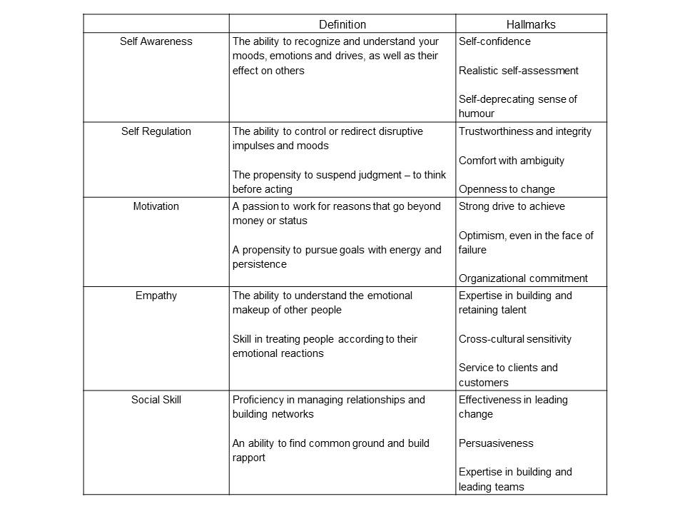

**Can emotional intelligence be learned?**

* Are people born with certain levels of empathy for example or do they acquire empathy as a result of lifes experiences? Answer is both.
* Psychological and developmental research indicates that nurture play a role aswel as genetics.
* On thing is certain emotional intelligence increase with age. : maturity.
* Some people still need training to enhcane their emotional intelligence. Many programms focused on developing leadership focus on the wrong part of the brain.
* Emo intel born largely in neurotransmitters of brains limbic system that learns best through motivation, extended practice and feedback.
* To enhace emo intel orgs must refocus their training to include the limbic system. Must help people to break through old behavioural habits and establish new ones. Requires an individualised approach.
* Empathy is heightened through practice and feedback.
* Its important to empahsise that building ones emotional intelligence cannot will not happen without sincere desire wnad concerted effort.
* Nothgin great was ever achieved without enthuasiasm- Ralph emerson.
* If your goal is to become a real leader, these words can serve as a guidepost in your efforts to develop high emo intelligence.